FOUNDATION UNIVERSITY ISLAMABAD
SCHOOL OF SCIENCE AND TECHNOLOGY

LAB MANUAL 5

NAME: ALISHBA HAFEEZ
SUBJECT: PF(programming fundamentals)
SECTION: 25(B)
DEPARTMENT: BS IET
ROLL NO: 056
FORM NO: 1025234338
INSTRUCTOR: Mr. SHAMSHAIR

TASK 5.1:
for Statement
Write a C++ program that takes an integer input from the user, prints all even integers less than or equal to this number and greater than or equal to 0, calculates the sum of these even, and displays results on the screen. Your program should have the following interface.

CODE:
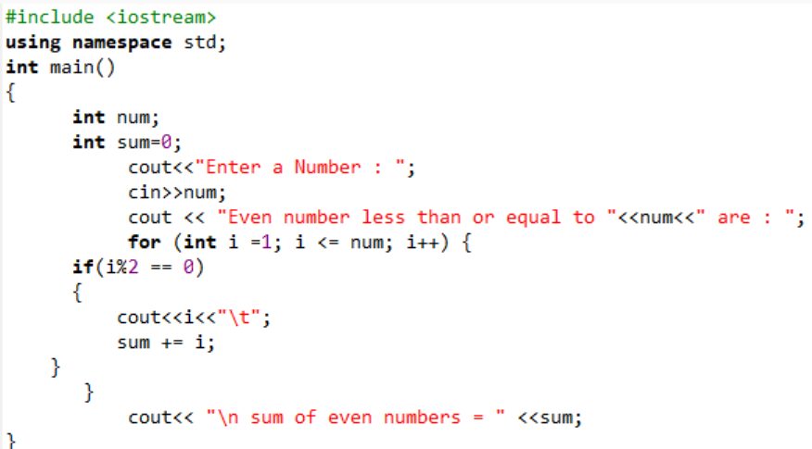

OUTPUT:
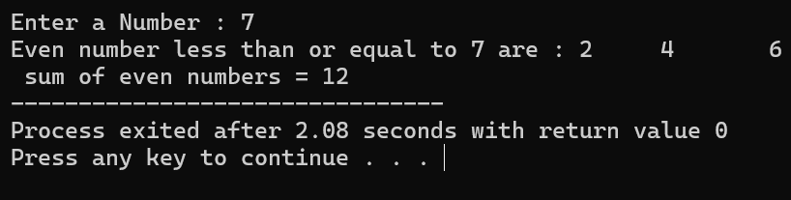

TASK 5.2:
while Statement
Repeat Task. 5.1 using while loop.

CODE:
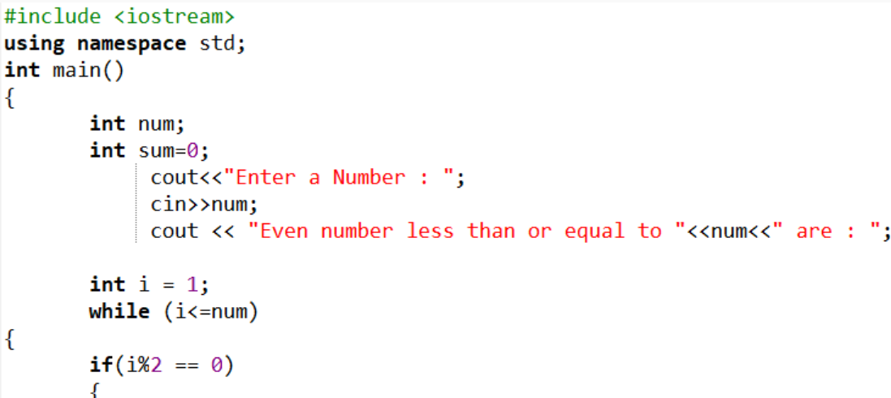
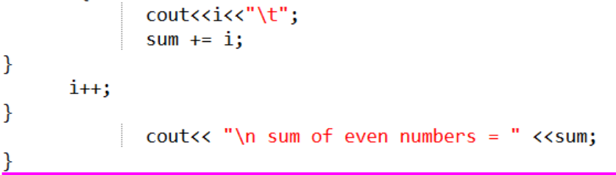

OUTPUT:
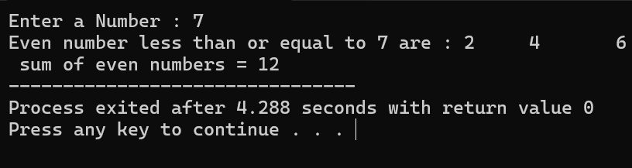

TASK 5.3: Write a C++ program that takes an integer input from the user in the variable named ‘num’, calculates
the sum of all integers from 1 to ‘num’, and displays this sum on screen. Your program should have the following interface.

CODE:
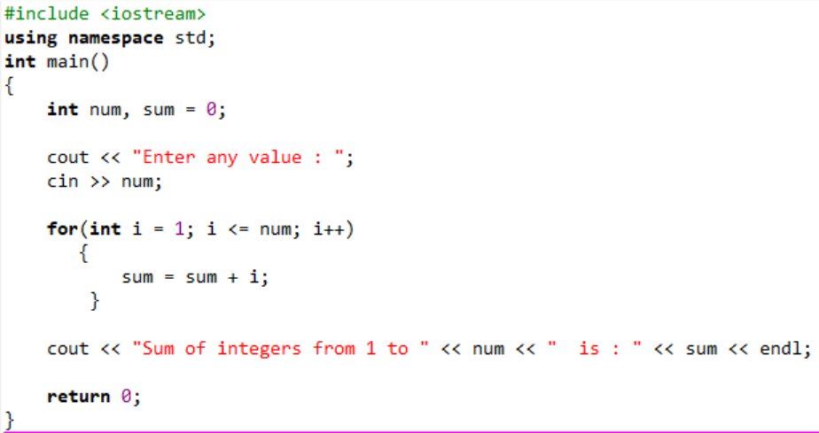

OUTPUT:
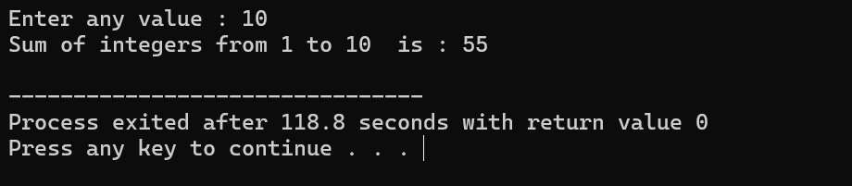

TASK 5.4: Write a program to calculate the factorial of number input by user using both for and while loops.
CODE:
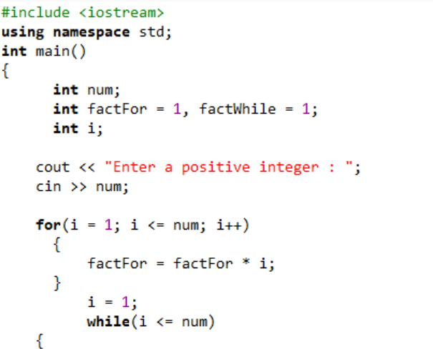
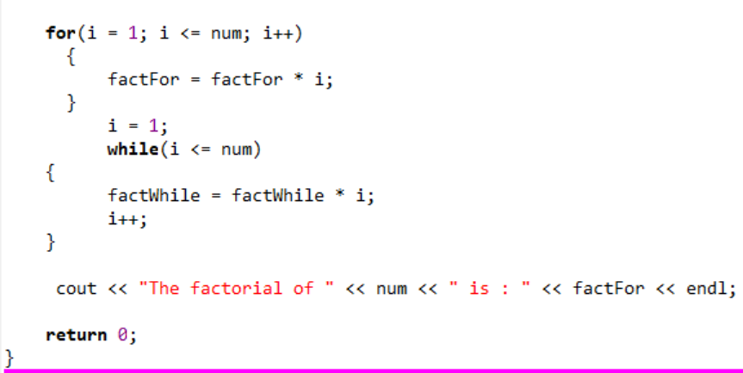

OUTPUT:
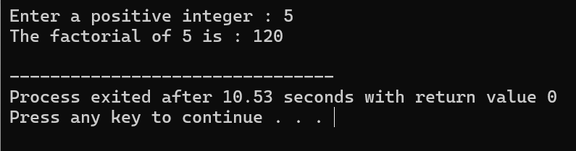

TASK 5.5:
Show the output of the following code.

CODE:
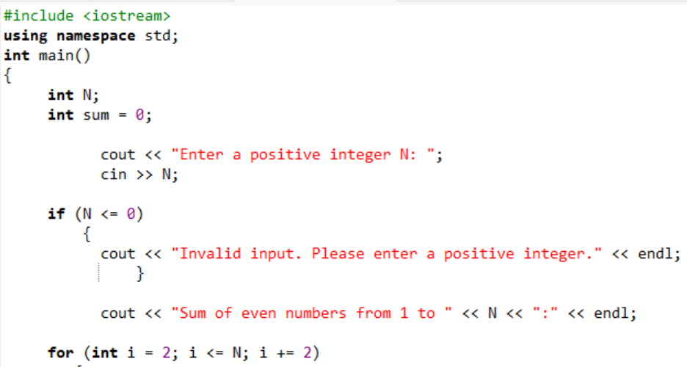
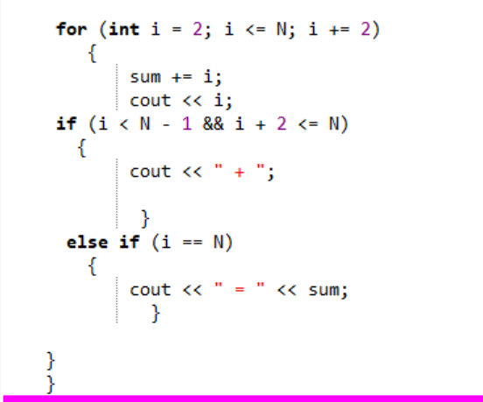

OUTPUT:
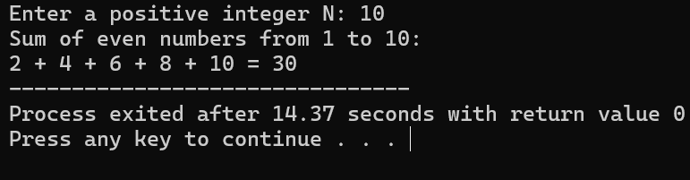
TASK 5.6:
Show the output of the following code
CODE:
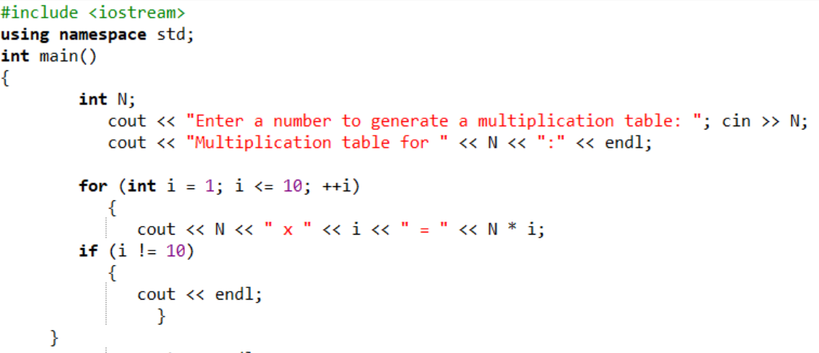
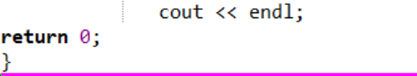

OUTPUT:
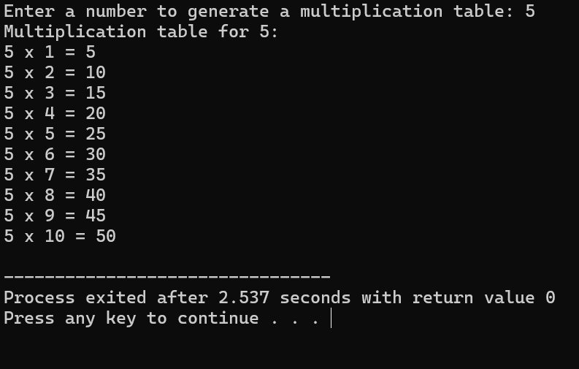

TASK 5.7:
Show the output of the following code.
CODE:
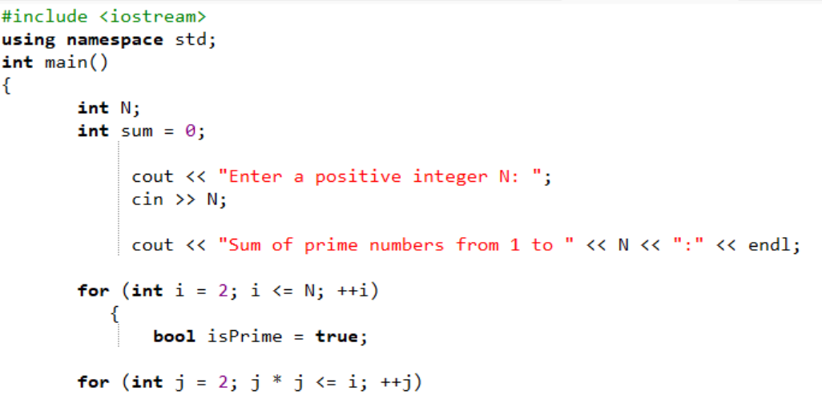
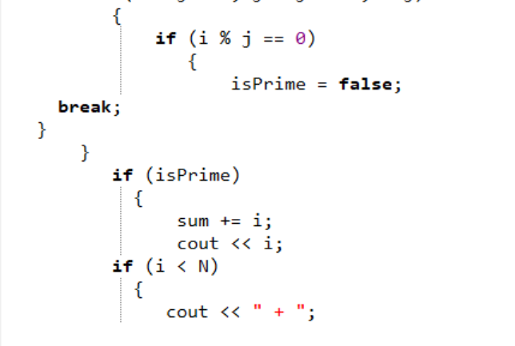
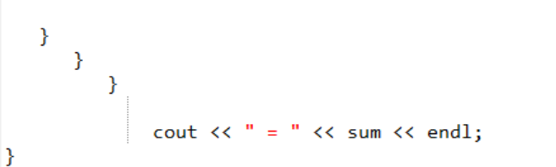

OUTPUT:
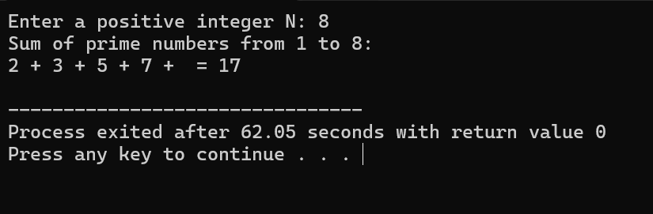
TASK 5.8:
Show the output of the following code.

CODE:
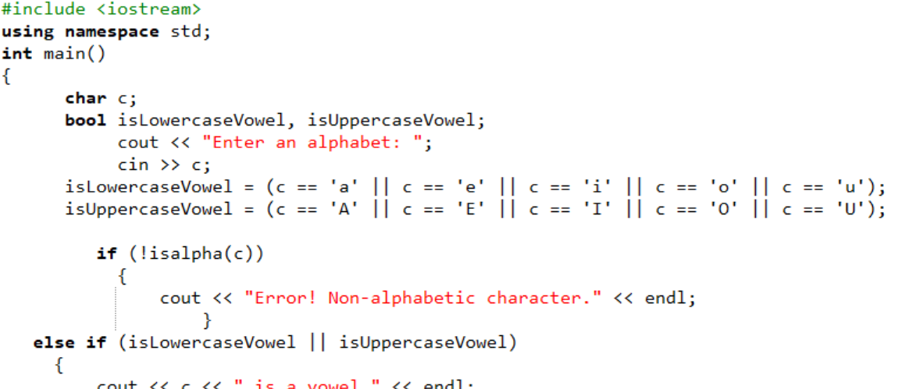
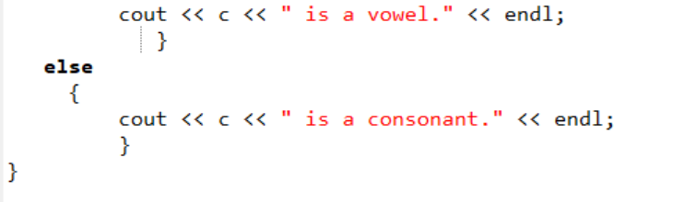

OUTPUT:
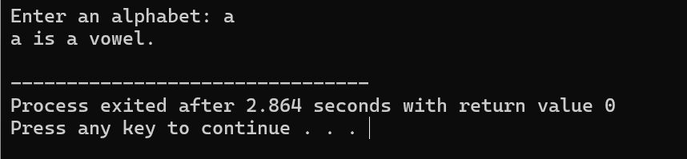

TASK 5.9:
Show the output of the following code.

CODE:
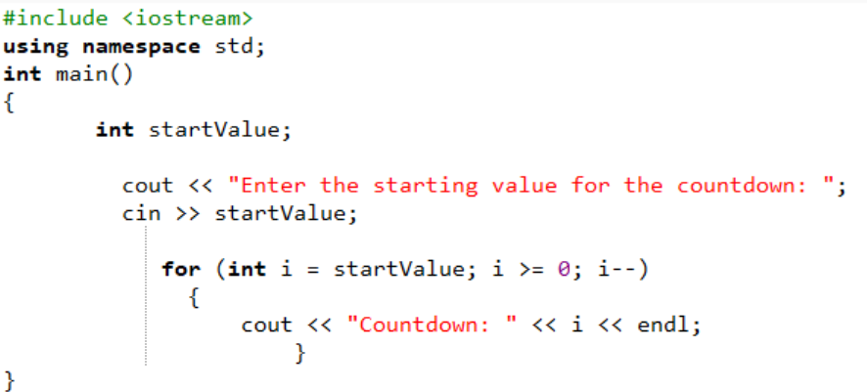

OUTPUT:
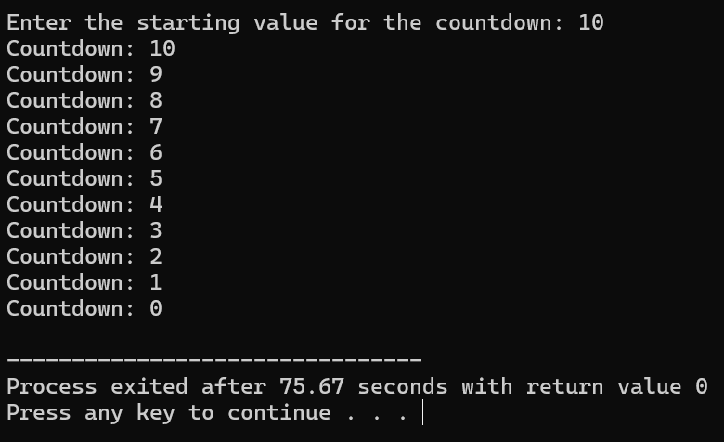

EXERCISE 5.1:
Repeat Task 5.1 using ‘do/while’ statements.
CODE:
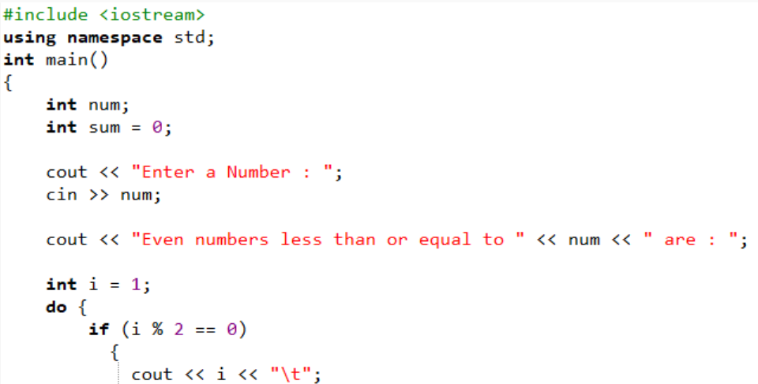
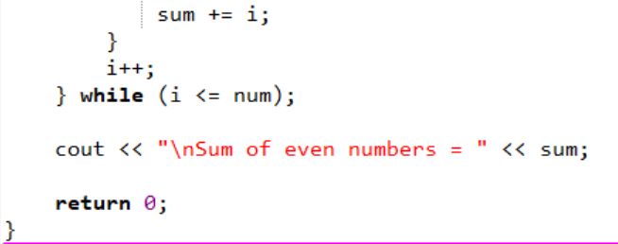

OUTPUT:
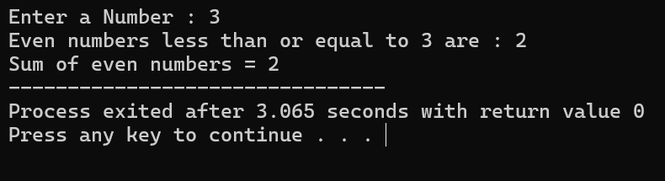

EXERCISE 5.2:
Develop a C++ program that calculates and displays the factorial of a positive integer using a for loop with decrement. Prompt the user for an integer and then calculate its factorial. Explain the decrement logic in your comments.

CODE:
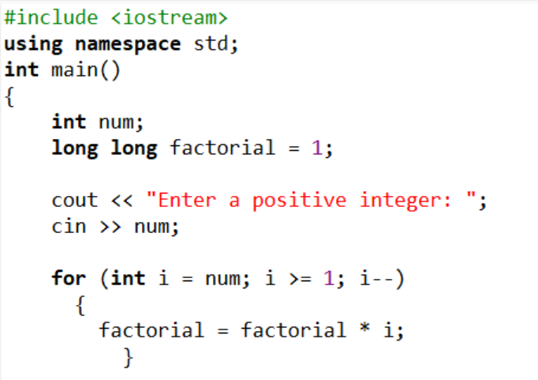
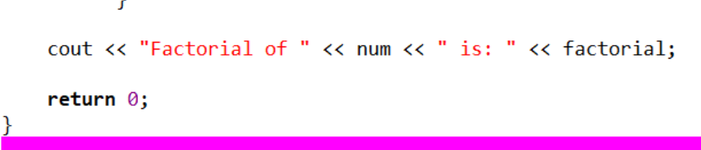

OUTPUT:
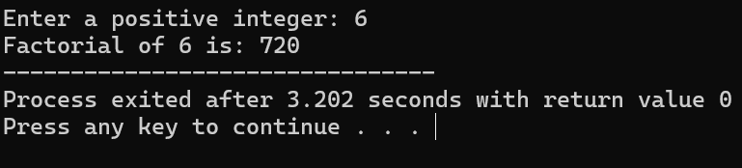

EXERCISE 5.3:
Develop a C++ program that calculates and displays the sum of all even numbers from 100 down to 1 using a for loop with decrement. Explain the loop's decrement logic in your comments.

CODE:
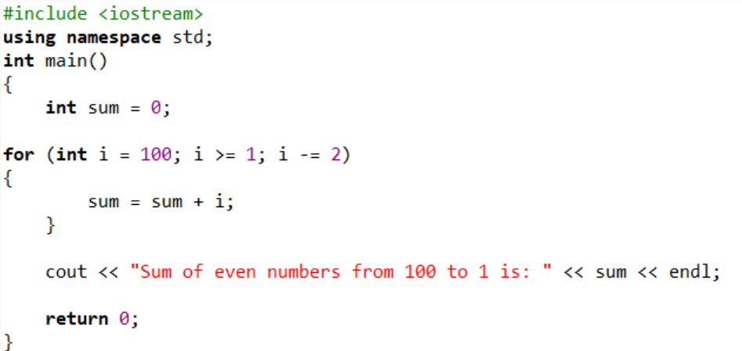

OUTPUT:
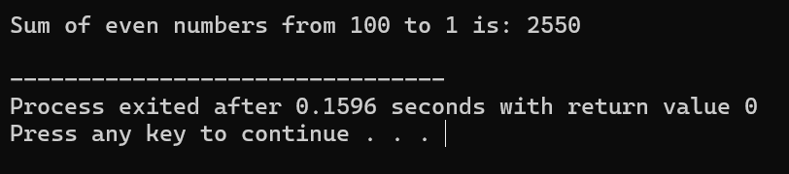
EXERCISE 5.4:
Write a C++ program that prompts the user for their age and keeps asking until they enter a valid age (between 1 and 120). Use a do-while loop to validate the input.

CODE:
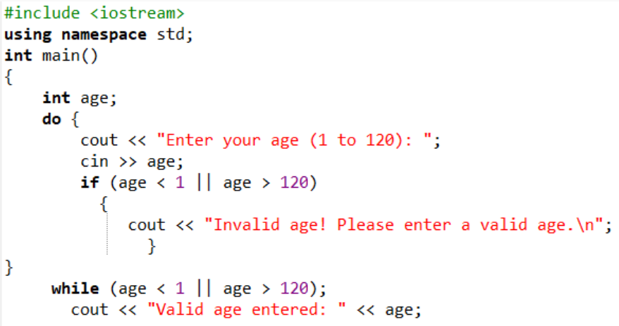


OUTPUT:
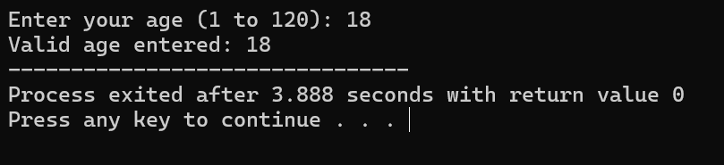

EXERCISE 5.5:
Write a C++ program to simulate a simple ATM machine. The program should allow the user to deposit or withdraw funds and display the balance. Use a while loop and switch statement to repeatedly provide options until the user chooses to exit. Explain the loop's menu-driven logic in your comments.

CODE:
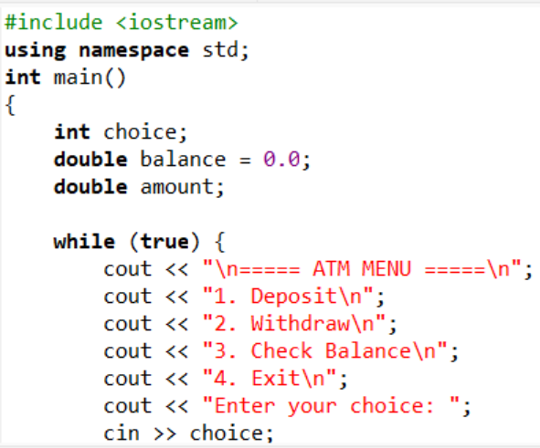
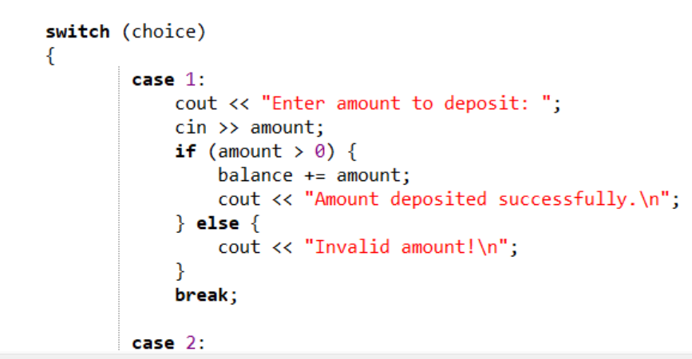
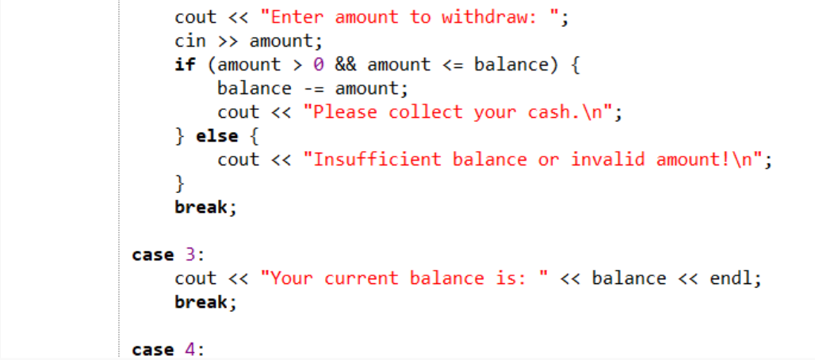
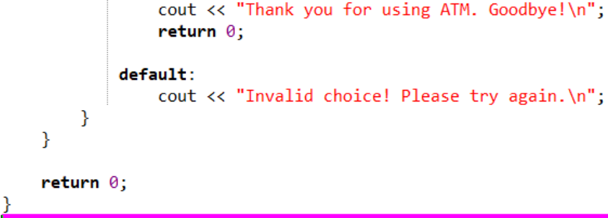
OUTPUT:

